October 12

Insight from Rob K:
Bill;
Nothing new here, eh? Note the complete and utter disconnect as to how China can be importing 24 % more crude – year over year – in the face of declining output from the world’s super giant oil fields [Cantarell – Mexico, Burgan – Kuwait, Ghawar – Saudi Arabio, Prudhoe Bay – Alaska, North Sea etc.] Never mind the fact that the U.S. Gulf Coast never did recover from lost production of both nat. gas and crude in the wake of Katrina – much of which has NEVER been replaced.
Geepers Bill, if we are to believe government reports, there is so much oil sloshing around in the world – that Ripley’s Believe It or Not - the Strategic Petroleum Reserve was even able to "top up" to the tune of an additional 800,000 barrels thus far in October?
The anecdotal data above IS INCONSISTENT WITH DECLINING PRICES OF ENERGY.
The explosive growth of derivatives goes far to explain how / why prices are declining. 5.5 TRILLION GROWTH in a derivatives book at one bank in one freaking quarter should be sounding ALARM BELLS all over the world as to what is really going on.
Has it occurred to anyone that physical inventory in the SPR is about as easily counted and measured as the GOLD in Ft. Knox or West Point?
Best,
Rob
http://biz.yahoo.com/ap/061012/china_oil_reserves.html?.v=1
China's Oil Imports Surge to Record High
Thursday October 12, 7:23 am ET
By Elaine Kurtenbach, AP Business Writer
China's Oil Imports Surge to Record High As Country Begins Filling Strategic Reserves
SHANGHAI, China (AP) -- China's oil imports surged to a record high 3.3 million barrels a day in September, the government reported Thursday, as the country recently began filling its newly built strategic oil reserves.
Preliminary data from the General Administration of Customs showed crude oil imports jumped 24 percent over the same month a year earlier to 13.5 million metric tons (15 million U.S. tons) in September.
That would be an all-time high for any month, beating the 13.2 million tons of crude oil China imported in January, said David Hurd, a Beijing-based oil and gas research analyst at Deutsche Bank.
China recently completed construction of a storage facility in Zhenhai, a city south of Shanghai, the first of four planned strategic oil reserves. Filling of those tanks began in August with a shipment of Russian crude from the Urals, state media reported earlier this week……
-END-
More from Rob:
Bill;
Take a look at this: The government’s EIA says that, "For the first 6 months of 2006, average demand was down 130,000 bbl/d, or 0.6 percent, from the previous year due to mild weather—which reduced heating oil, residual fuel oil,…."
But according Wikipedia, distillate usually refers to fuel oils produced through distillation, such as diesel and heating oil. This distinguishes them from the residual fuel oils, which are made from the residue left after distillation.
THIS IS CLEARLY A LIE, The EIA goes on to show in the graph below that DISTILLATE growth is POSITIVE!!!!! What I’d really like to know is what OTHER is – because that is what is making their annual demand projections appear "negative"?
These guys cannot even LIE properly. And they ARE LYING.
Best,
Rob Kirby
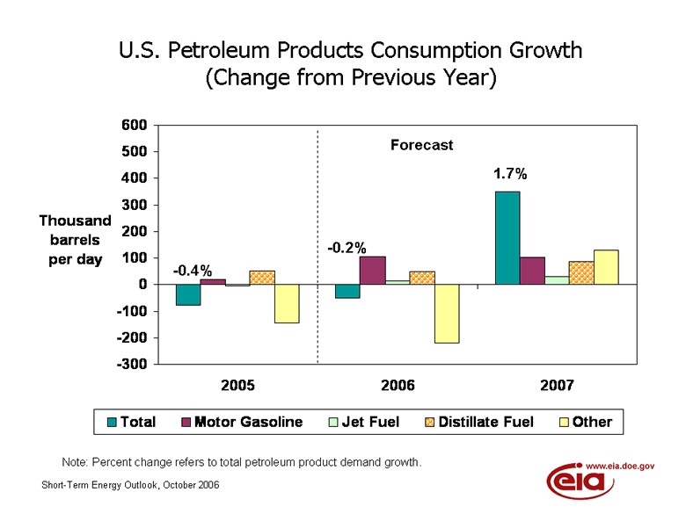
Bill;
Further to my earlier commentary, if there is anyone who still doesn’t "GET IT" consider the following:
To get your head around how ole J.P. Morgan manages energy risk, we need look no further than their own web site, where they’re more than happy to tell us,
Risk magazine, January 2006
J.P. Morgan was named Risk magazine’s Energy derivatives house of the year in their January issue. According to Risk, "J.P. Morgan has emerged as a key player in energy derivatives over the past year." Since 2004, under the guidance of Beau Taylor, global co-head of Energy, the firm has built a leading energy trading practice. Focus has extended from natural gas and crude exotic derivatives to include electricity, coal and emissions trading.
Energy Derivatives House of the Year – yeah right, just like Goldman Sachs is the Precious Metals Derivatives Trading House of the Year.
If this was not so BRUTAL!!!! I’d laugh
Best,
Rob Kirby

